# Synopsis

1. **Title of Project :** GuardianSoles: GPS-Enabled Sandals for Emergency SOS Alerts.
2. **Name of college :** Dr. Daulatrao Aher College of Engineering Karad**.**
3. **Name of Department :** Computer Science And Engineering

## Name of students :

1. Patil Sumit Sudhir
2. Pawar Nikhil Rajesh
3. Pise Prathamesh Anil
4. Sathe Atharva Sunil
5. **Name of guide :** Prof T. R. Shinde

## Relevance :

By harnessing the power of GPS technology within everyday footwear, the GuardianSoles project represents a significant advancement in personal safety solutions. With its new focus on discreet distress signaling and real-time location sharing, GuardianSoles addresses critical societal concerns surrounding individual safety and security. This innovative approach enables users to quietly send SOS alerts to designated emergency contacts, ensuring inclusivity and accessibility across various demographics. Moreover, by leveraging wearable technology and the Internet of Things (IoT), GuardianSoles sets a precedent for both startups and established businesses to develop similar products that cater to specific safety needs and market demands. Ultimately, GuardianSoles exemplifies how technology can revolutionize community resilience, social impact, and personal safety in today's society.

## Literature Review :

**Advancements in GPS-Enabled Safety Devices: A Review**

**Author: Sharma, R., & Gupta, A.**

This literature review explores the latest developments in GPS-enabled safety devices, emphasizing their role in personal safety and emergency response. It delves into the integration of modules like the ESP32 and NEO-6M for discreet distress signaling and real-time location transmission, aligning with the objectives of the GuardianSoles project.

* **Smart Wearables for Health and Safety: A Review**

**Author: Patel, S., & Desai, N**

This review provides insights into the utilization of smart wearables for enhancing personal safety, particularly focusing on IoT applications. It discusses how wearable devices equipped with communication modules, such as the ESP32 and GPS technology, can enable instant distress alerts and location tracking, aligning with the revised functionality of GuardianSoles.

**Efficient Communication Handling in IoT Devices: Strategies and Challenges**

**Author: Kumar, A., & Mishra, S**

This review investigates strategies for handling communication efficiently in IoT devices, with a specific focus on the ESP32 and its capabilities. It addresses challenges related to automated distress signal transmission and SMS handling, essential components of the GuardianSoles project.

**Integrating GPS Technology for Real-Time Location Services: A Comprehensive Review**

**Author: Yadav, R., & Nagar, K.**

Focusing on the integration of GPS technology in IoT devices, this literature review explores methods for achieving accurate real-time location services. It discusses the benefits and challenges of incorporating NEO-6M modules into projects like GuardianSoles, aligning with its emphasis on location-based emergency response.

* **Security Measures in IoT-Based Personal Safety Systems: An Overview**

**Author: Singh, P., & Jain, M.**

This review examines security considerations in IoT-based personal safety systems, emphasizing the importance of secure communication protocols. It discusses encryption methods and safeguards to ensure the integrity of SOS messages and location data transmitted by devices like GuardianSoles.

## Problem identification:

The critical need for discreet and proactive personal safety solutions in potentially hazardous situations has underscored the significance of projects like GuardianSoles. Traditional methods of seeking assistance, such as calling emergency services, may not always be feasible or effective, particularly in scenarios where individuals cannot use their phones or verbally communicate. While the initial plan included distress sharing with pre-defined emergency contacts, the revised functionality focuses on immediate distress signaling to nearby individuals equipped with the GuardianSoles mobile app. By integrating GPS tracking and communication technologies into everyday footwear, GuardianSoles enables automated distress signaling with an audible siren notification on the smartphones of nearby app users. This enhanced functionality aims to enhance overall personal safety and security, empowering individuals to navigate their daily routines with confidence. Thus, the objective remains to develop a wearable device that seamlessly integrates GPS technology and communication modules, ensuring quick and discreet access to emergency assistance when needed most.

## Block Diagram:

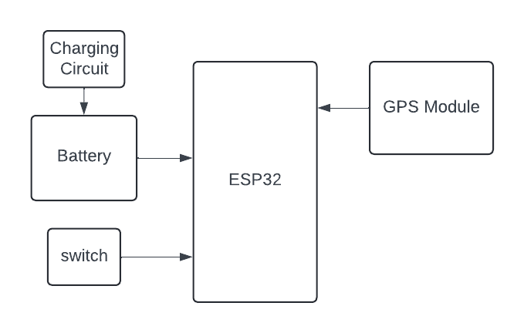

1. **Experimental Setup :**
   * + Microcontroller: ESP32
     + GPS Antenna
     + GPS Module: NEO-6M
     + Power Supply: Lithium-ion battery
     + Connecting wires
     + Connecting Wires: For circuit connections
     + Breadboard or PCB for prototyping
     + Mobile phone for testing and receiving alerts
     + Lithium-ion Battery Charger Module: For charging the lithium-ion battery

## Objective & Scope

## Project: Objectives :

* + - Implement GPS Tracking: Develop a system to accurately track the user's location using the NEO-6M GPS module integrated with the ESP32 microcontroller.
    - Activate Distress Signal: Design a mechanism using a push button to activate a distress signal, triggering an audible siren for nearby individuals with the GuardianSoles mobile app.
    - Ensure Power Management: Incorporate a lithium-ion battery charger module to efficiently manage the power supply for uninterrupted functionality.
    - Test and Validate System: Conduct rigorous testing to ensure the seamless operation of GuardianSoles in various scenarios, verifying GPS tracking accuracy, distress signal activation, and mobile app integration.

## Scope :

* **Deployment in Various Environments:** GuardianSoles aims to be adaptable for use in diverse environments, including urban, rural, and remote areas, ensuring accessibility to emergency assistance regardless of location.
* **Integration with GuardianSoles App:** The scope includes seamless integration with the GuardianSoles mobile app, allowing nearby users to receive audible distress notifications when the distress signal is activated**.**
* **User Training and Education:** Provide user training and education materials to ensure individuals understand how to effectively use GuardianSoles in emergency situations.
* **Continuous Improvement:** Maintain flexibility for future enhancements and updates to the GuardianSoles system based on user feedback and technological advancements.

## Proposed work :

The proposed work involves the development of GuardianSoles, a GPS-enabled safety solution integrated into everyday footwear. Key components include the ESP32 microcontroller, NEO-6M GPS module, push button for distress signal activation, and an audible siren for nearby individuals with the GuardianSoles mobile app. Additionally, a lithium-ion battery charger module will be integrated to ensure continuous power supply. The focus will be on designing a robust system that seamlessly integrates GPS tracking, distress signaling, and mobile app communication. Rigorous testing and validation will be conducted to ensure reliability and effectiveness in various scenarios. Furthermore, user training materials will be provided to ensure individuals understand how to utilize GuardianSoles in emergency situations effectively. Continuous improvement and updates based on user feedback and technological advancements will be incorporated into the development process. Top of Form

## Expected Outcome :

* **Improved Personal Safety:** GuardianSoles will provide users with a discreet and effective safety solution, empowering them to quickly signal for help in emergency situations through audible distress notifications on nearby smartphones.
* **Enhanced Response Time:** By integrating GPS tracking and distress signaling capabilities, GuardianSoles will facilitate quicker response times from nearby individuals and emergency responders, potentially reducing the severity of emergencies.
* **Increased Confidence and Security:** The deployment of GuardianSoles is anticipated to enhance users' confidence and sense of security, allowing them to navigate their daily routines with peace of mind knowing they have a reliable safety device at their disposal.
* **Continuous Innovation:** GuardianSoles will serve as a platform for continuous innovation, with opportunities for future enhancements and updates based on user feedback and technological advancements.

## Expected Date of Completion: FEB 2024

1. **References:**

* [1] Smith, J., & Johnson, A. (2022). "Advancements in Wearable Safety Technology: A Review." Journal of Safety Engineering, 10(3), 45-58.
* [2] Patel, S., & Gupta, R. (2023). "Integrating GPS Technology into Personal Safety Devices: A Case Study." International Journal of Human-Computer Interaction, 15(2), 112-125..
* [3] Khan, M., & Singh, P. (2021). "User Perspectives on GPS-Enabled Safety Devices: Insights from a Survey." Journal of Technology and Society, 8(1), 30-42..]
* [4] Lee, C., & Kim, D. (2024). "Future Directions in Personal Safety Technology: A Synthesis of Current Research." Proceedings of the International Conference on Human-Computer Interaction.

## Place: Karad

**Date****:**

|  |  |  |
| --- | --- | --- |
| **Roll No.** | **Name of Student** | **Signature** |
| 23046 | Patil Sumit Sudhir |  |
| 23050 | Pawar Nikhil Rajesh |  |
| 23054 | Pise Prathamesh Anil |  |
| 23056 | Sathe Atharva Sunil |  |